CH GROCERS User Guide

Customer Guide

This customer guide will manage you through the highlights (main features) of the site and will likewise enable you to explore through our site easily. Likewise, to ensure you don't have the issue of perusing long, exhausting and pointless aides, we've attempted our best to make this short, straightforward and justifiable. On the off chance that you have any further questions that the guide couldn't deliver please don't hesitate to reach us on chgrocers123@gmail.com.

# User Registration

After going to our homepage you'll see register as customer on upper left of the site. Click on it to register after that you will be directed towards a registration form fill up the form and click on register. You will get an email from the admin with a link to activate your account click on the link to activate your account.

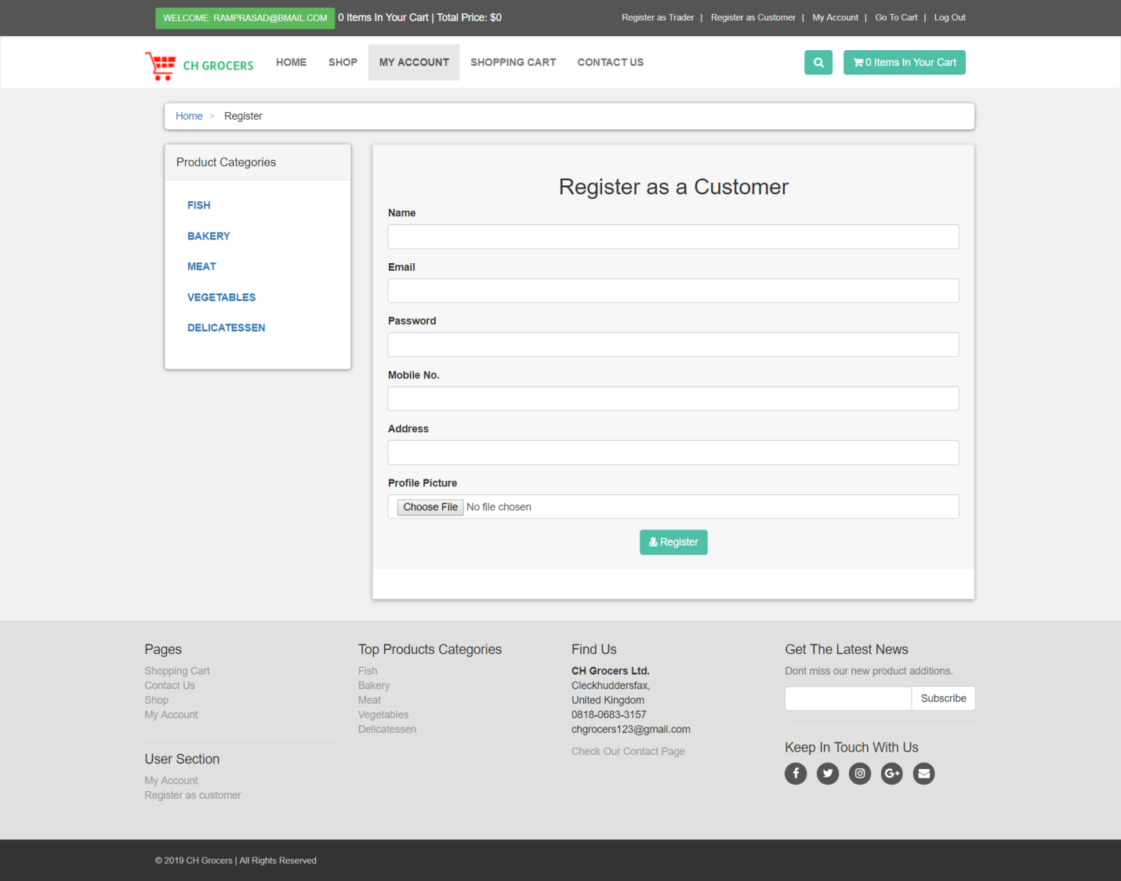

# User Login

You can log in as a customer after you click on the link sent by user. On homepage you will see login on right side of the site click on it and enter your email and password and click on login button to login.

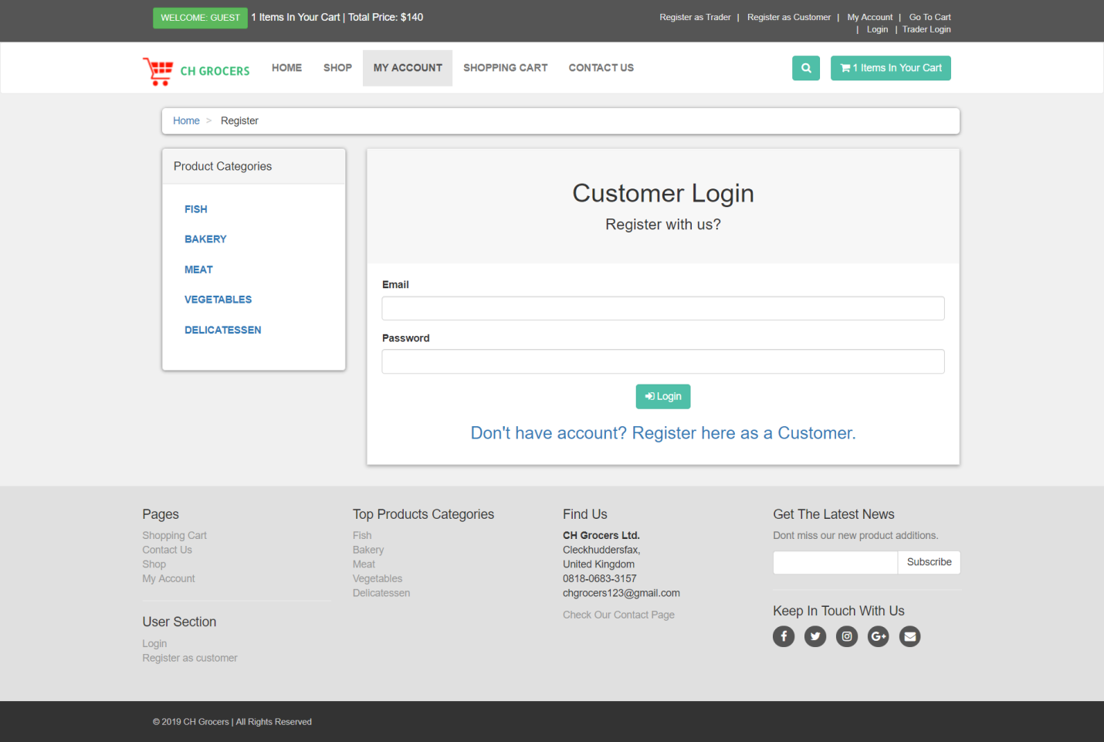

Product Browsing

You can browse products from shops and categories from different traders

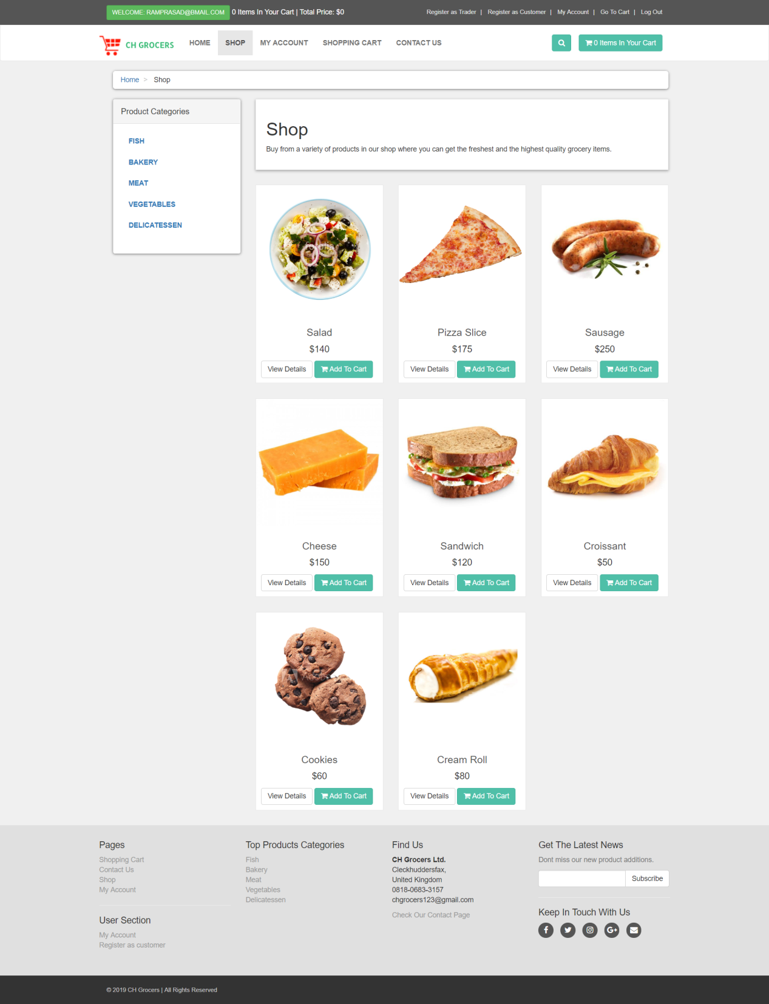

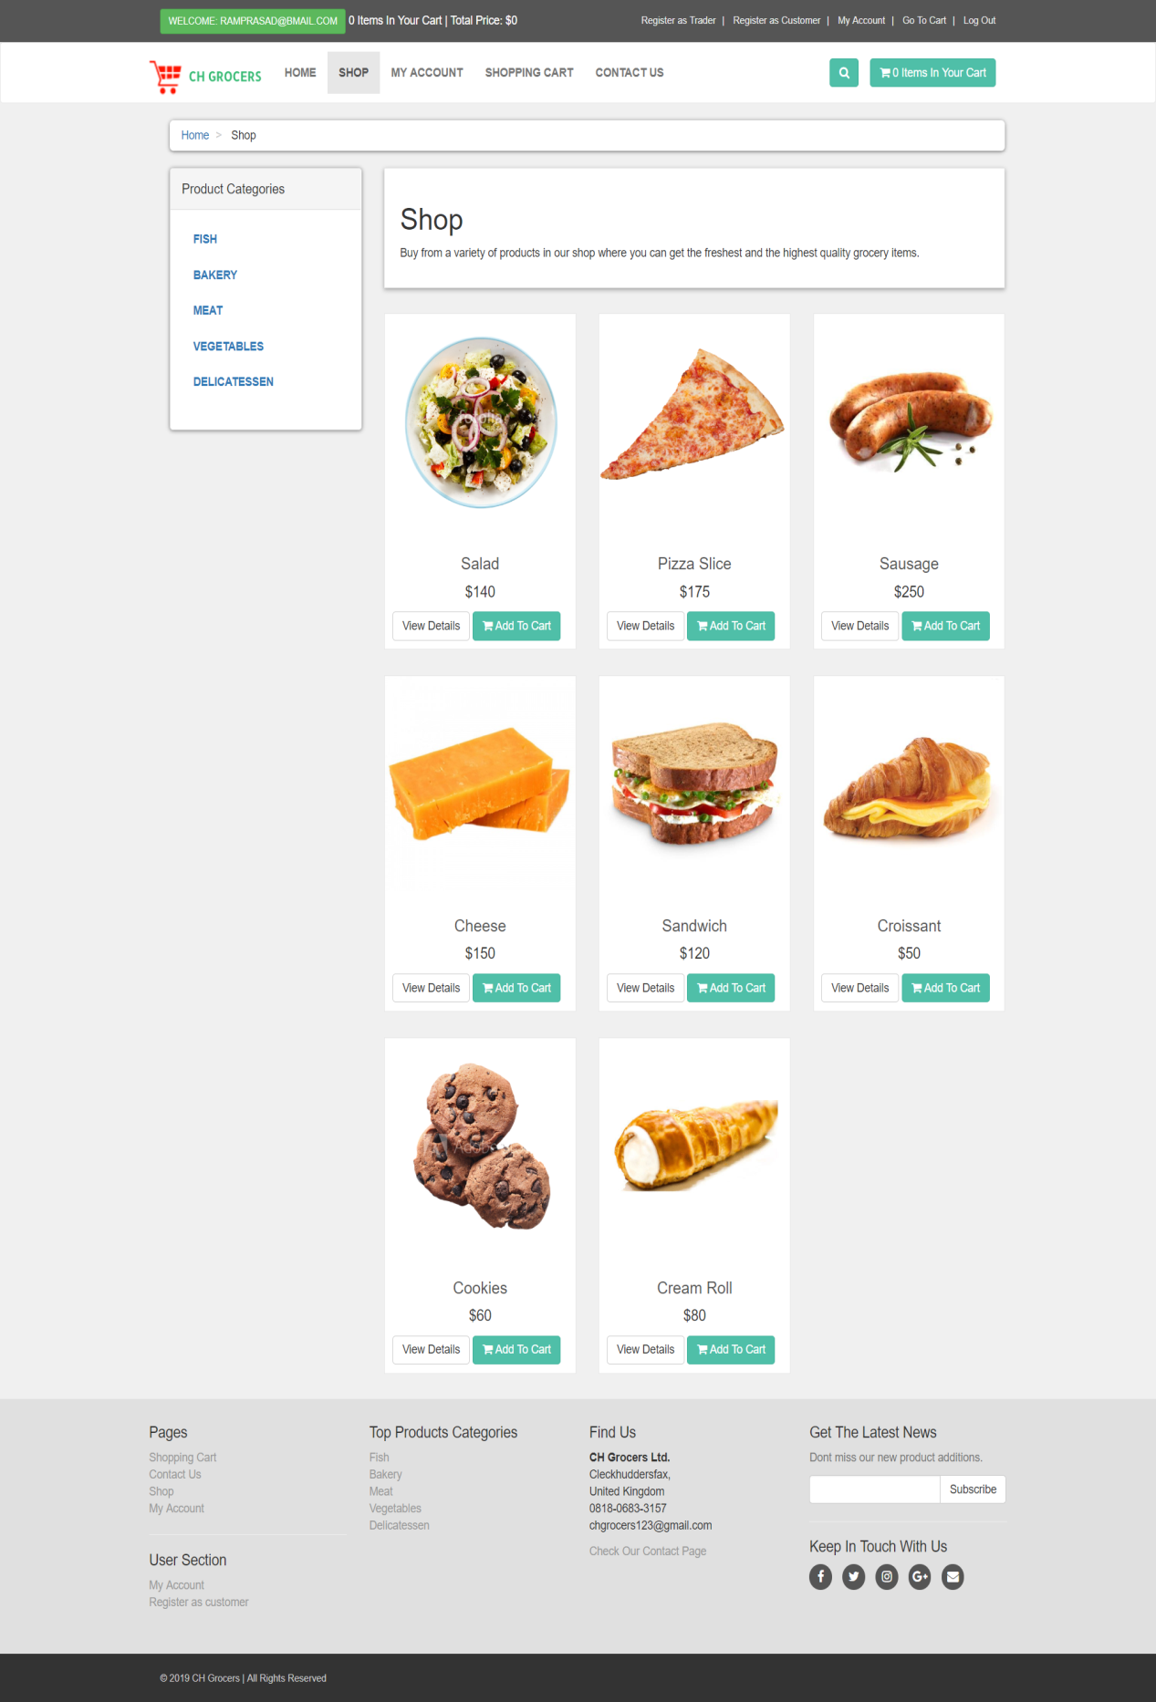

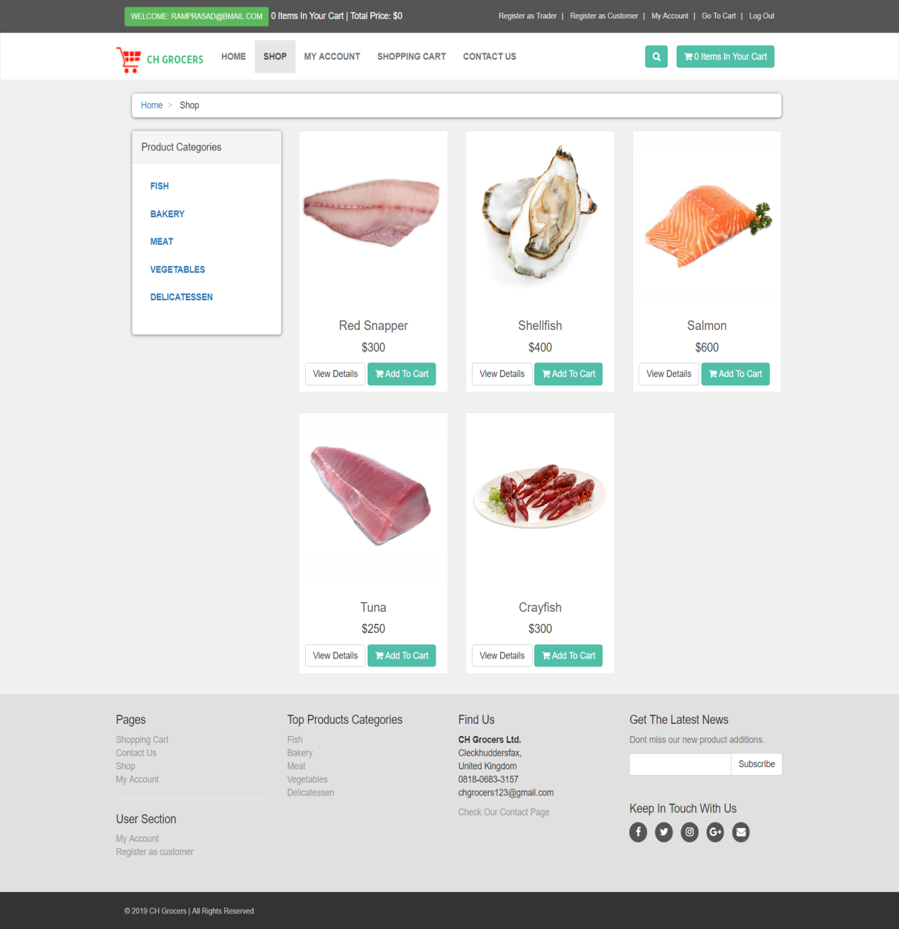

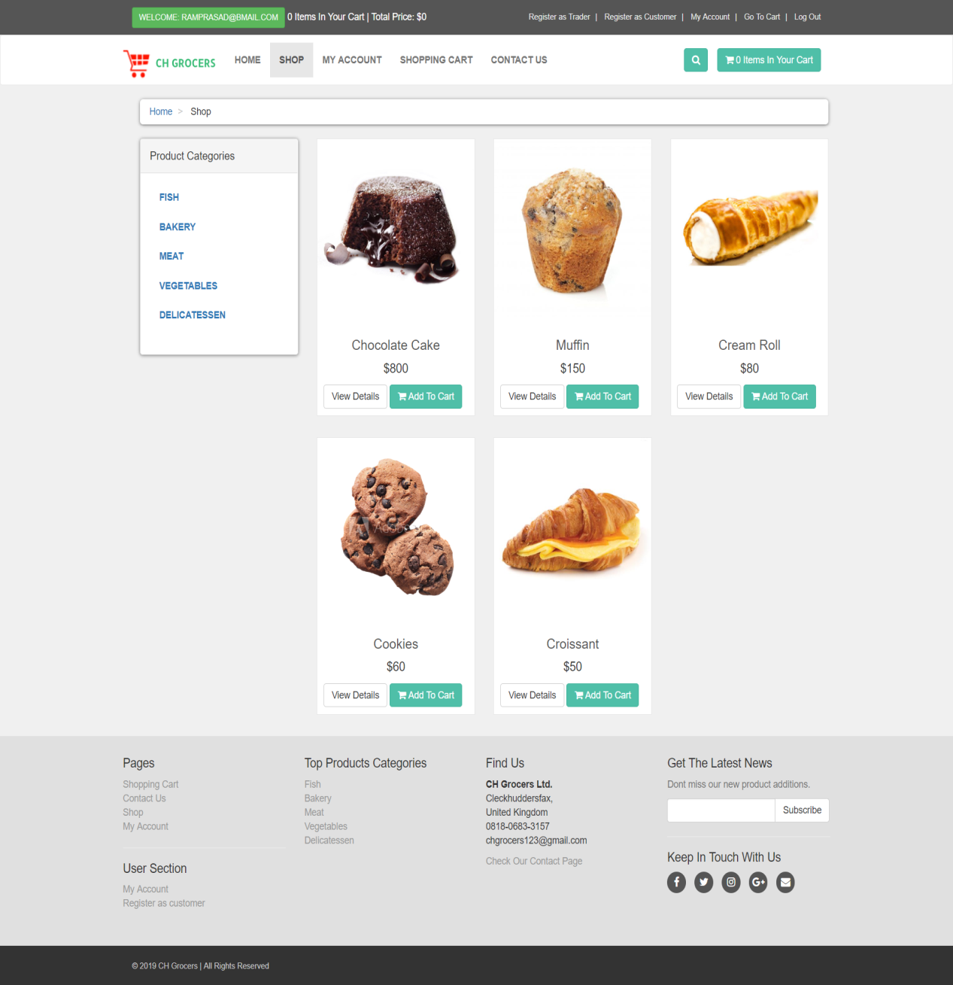

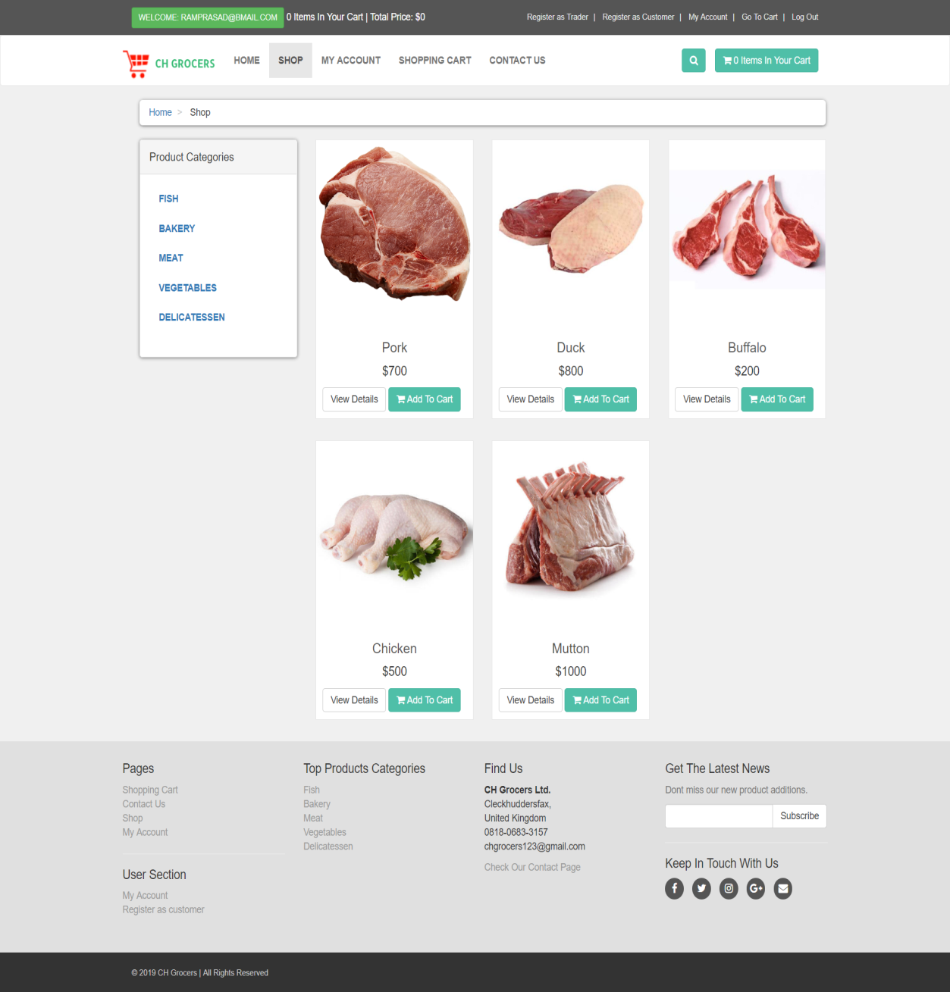

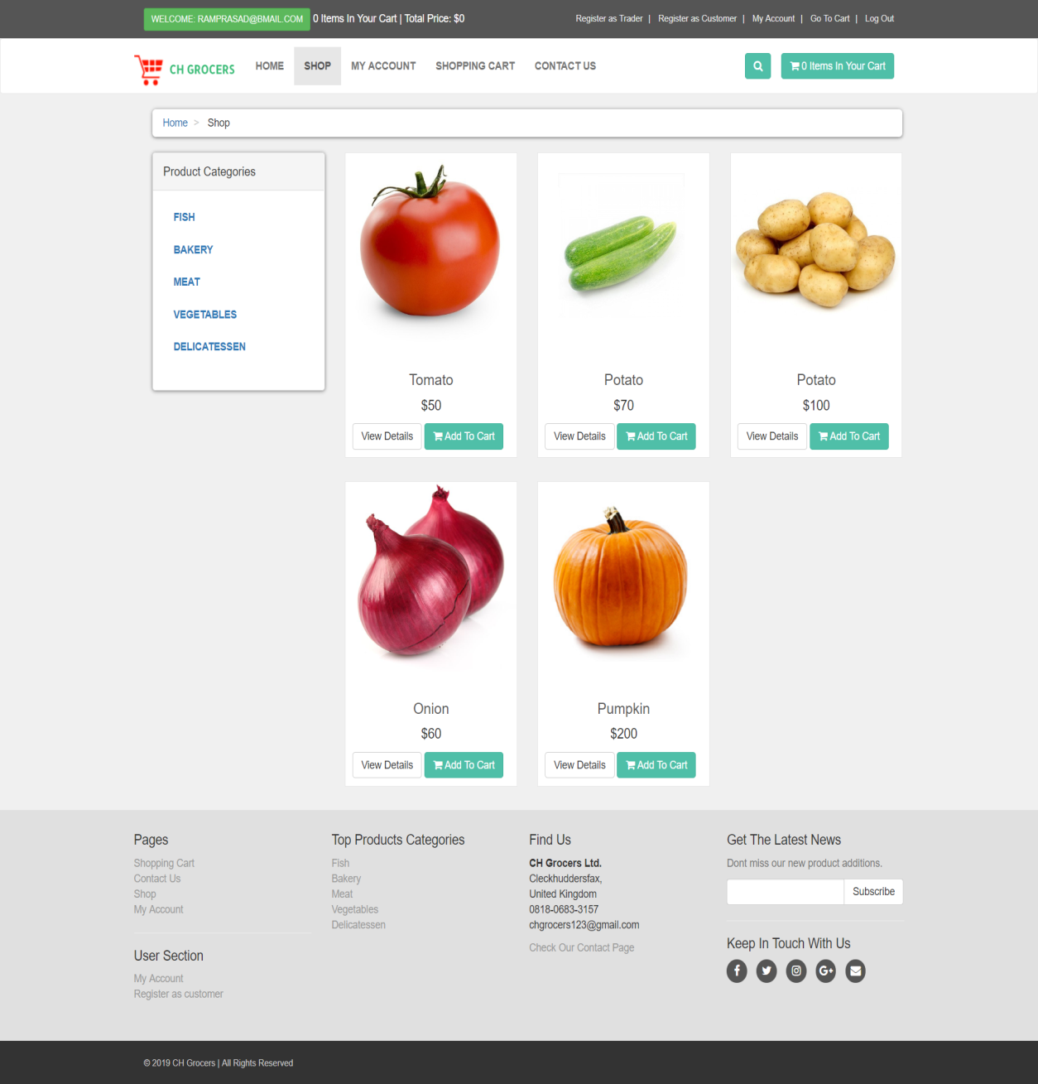

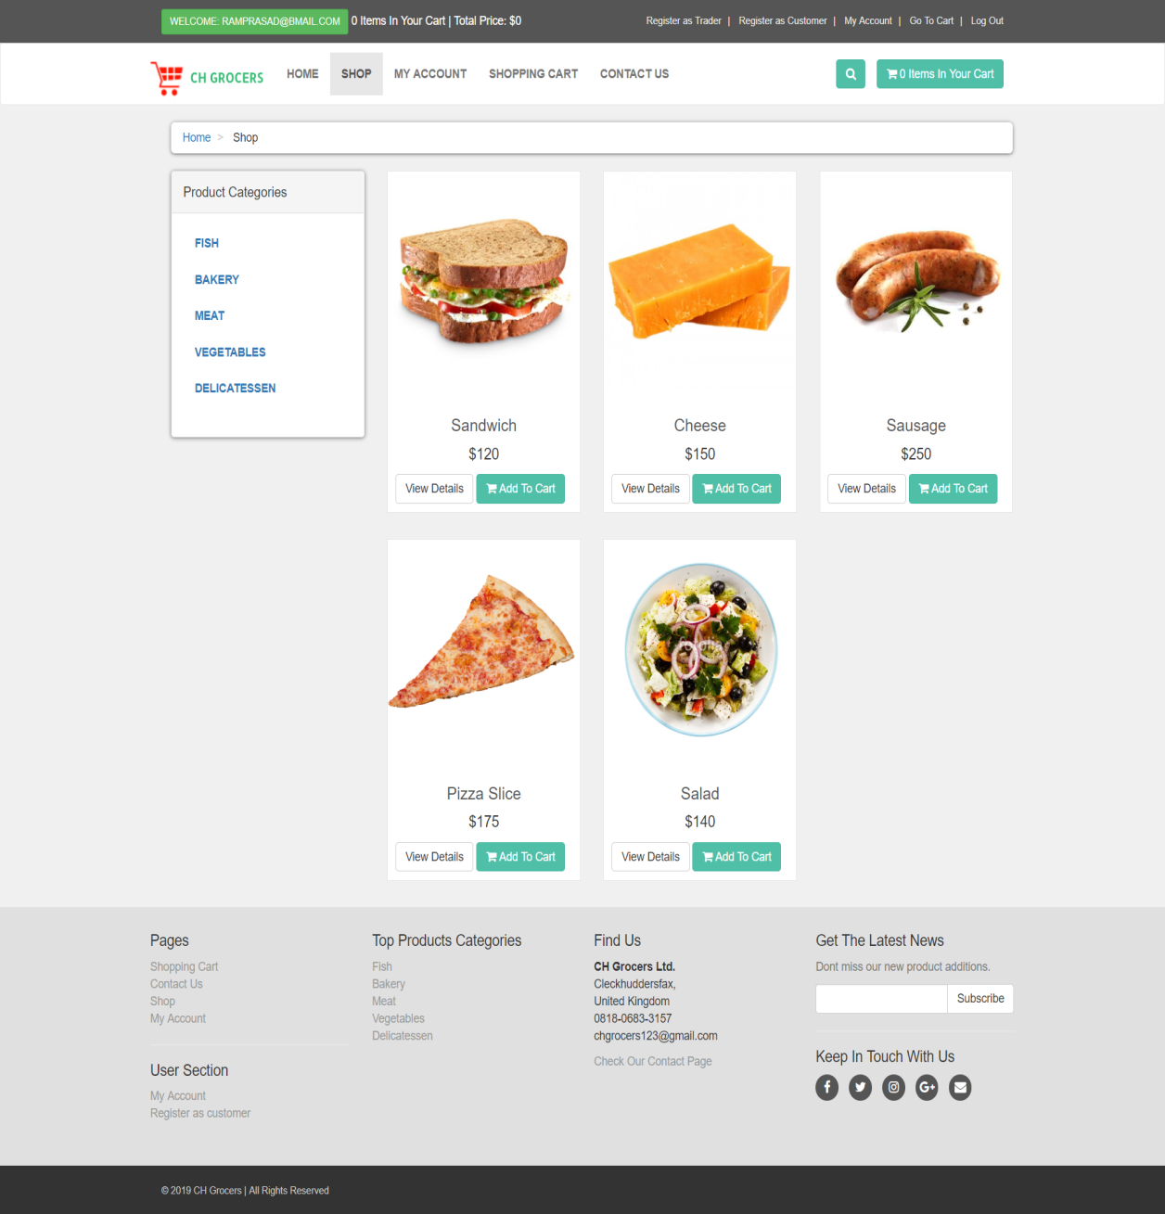

# 

# Adding Products to the Cart

You can add items to your cart by simply clicking on add to cart button. After clicking Add to cart button you will be directed towards a page where you can choose product quantity.

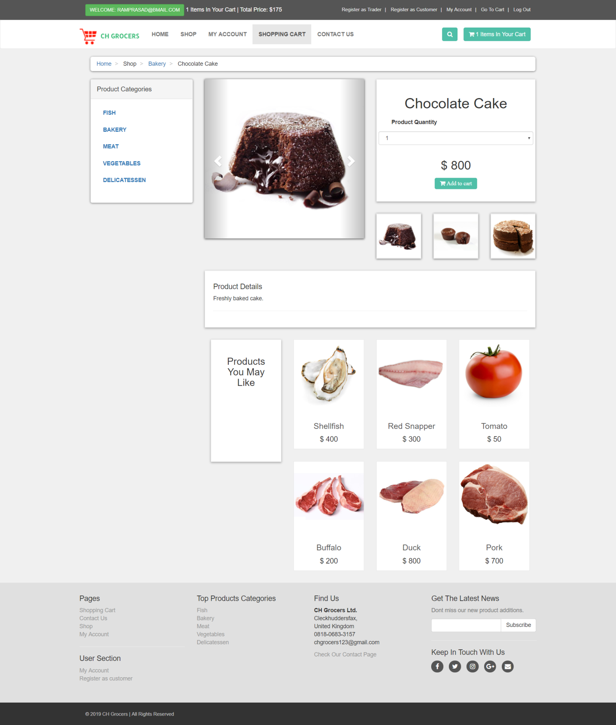

Viewing the Cart

Click on cart button on right hand of the site to view items in your cart you can also delete items added on your cart by simply checking delete checkbox and clicking on update cart.

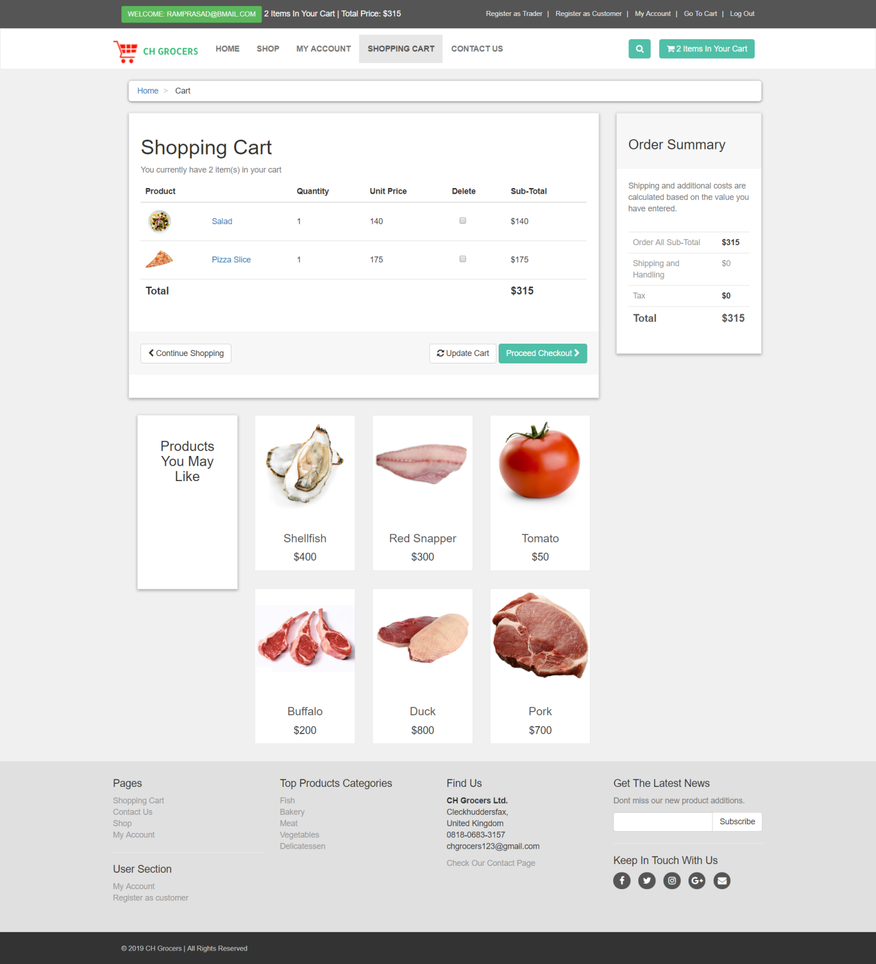

# Check Out

To checkout simply click on proceed checkout button after that you will be directed towards a page there you should choose your time of delivery and click on submit after that click on submit to process after that you directed towards pay pal login page

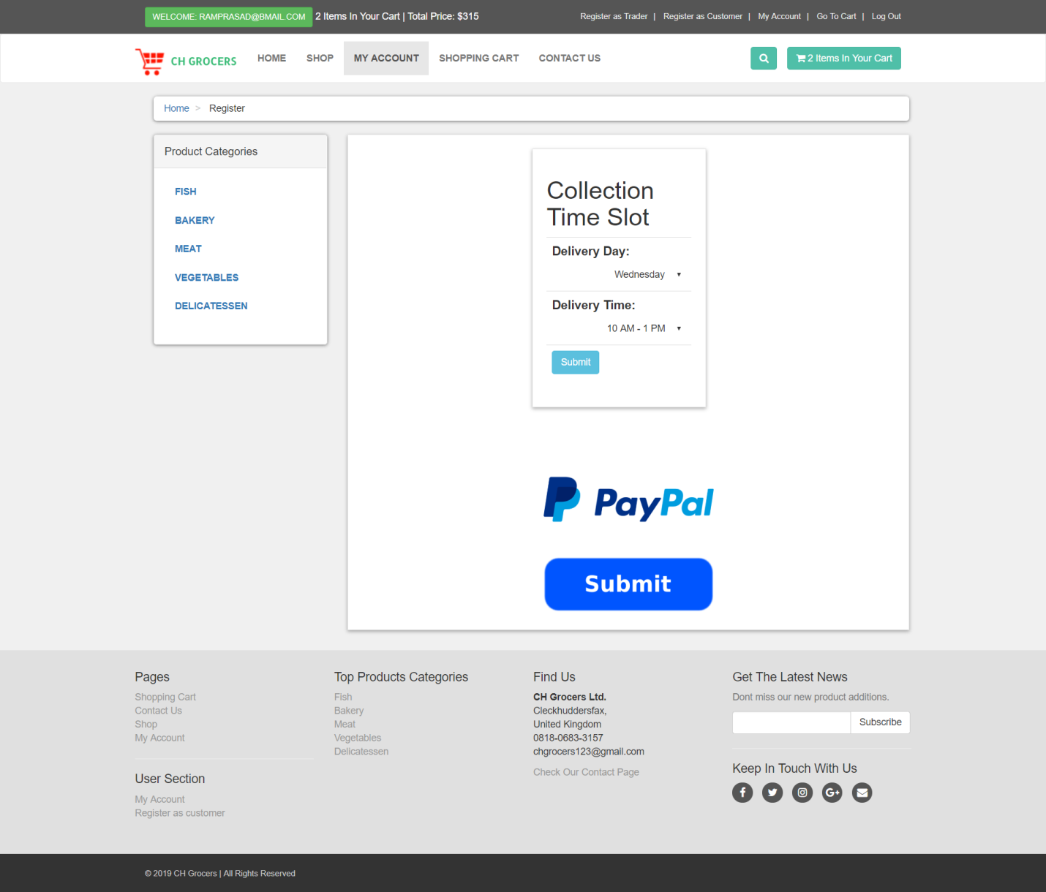

# 

# After login into pay pal you get this screen

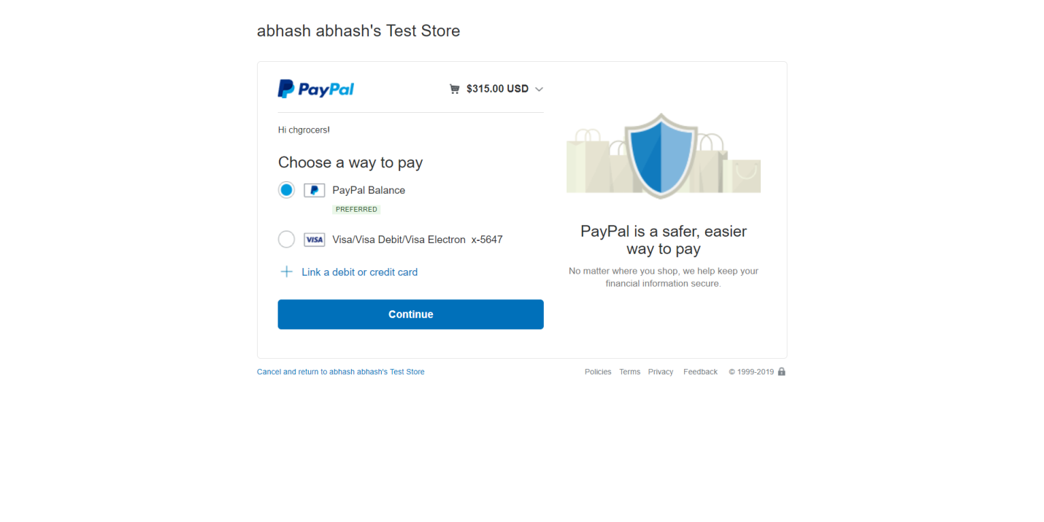Choose pay pal balance and click continue you will be forwarded to this page

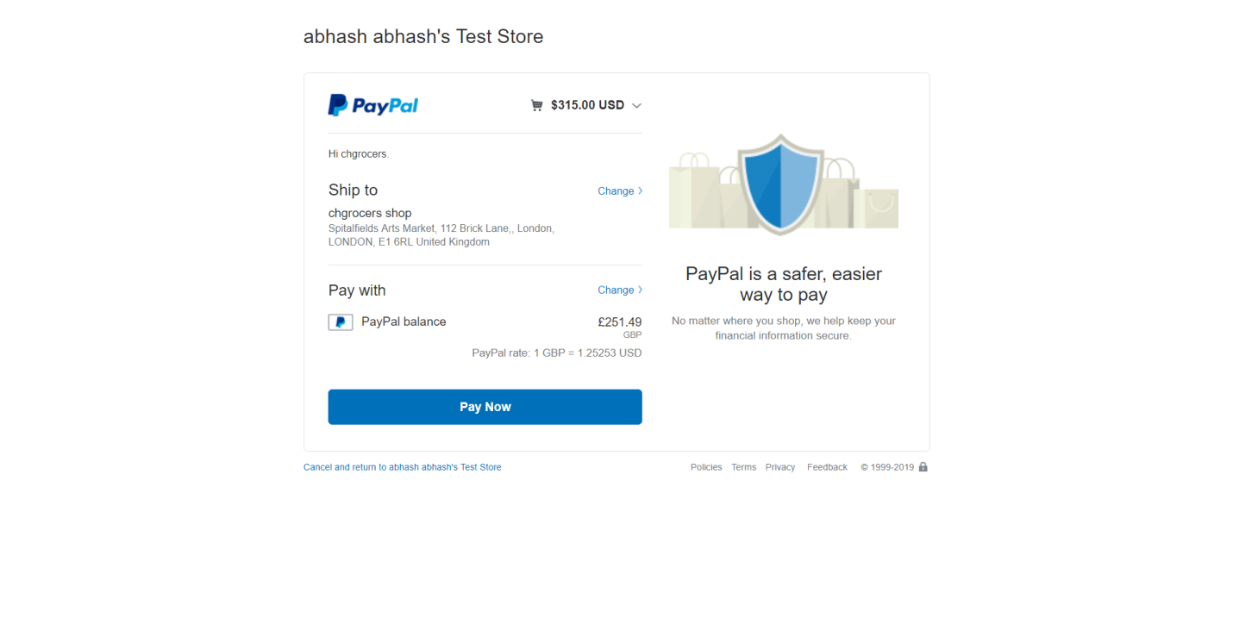

Click on pay now and the payment is complete and you will be directed towards this page

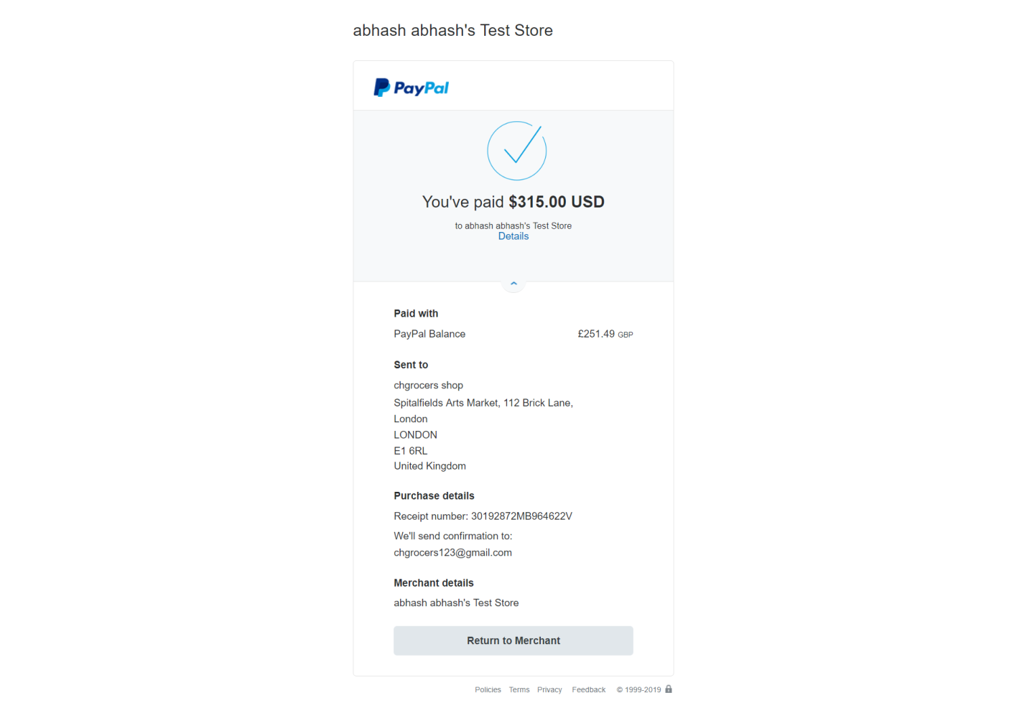

# 

# View orders, invoice

You can view your orders by clicking on my order on the sidebar there on left hand side you will find a view invoice button click it to view invoice and click on mail invoice button to invoice mail

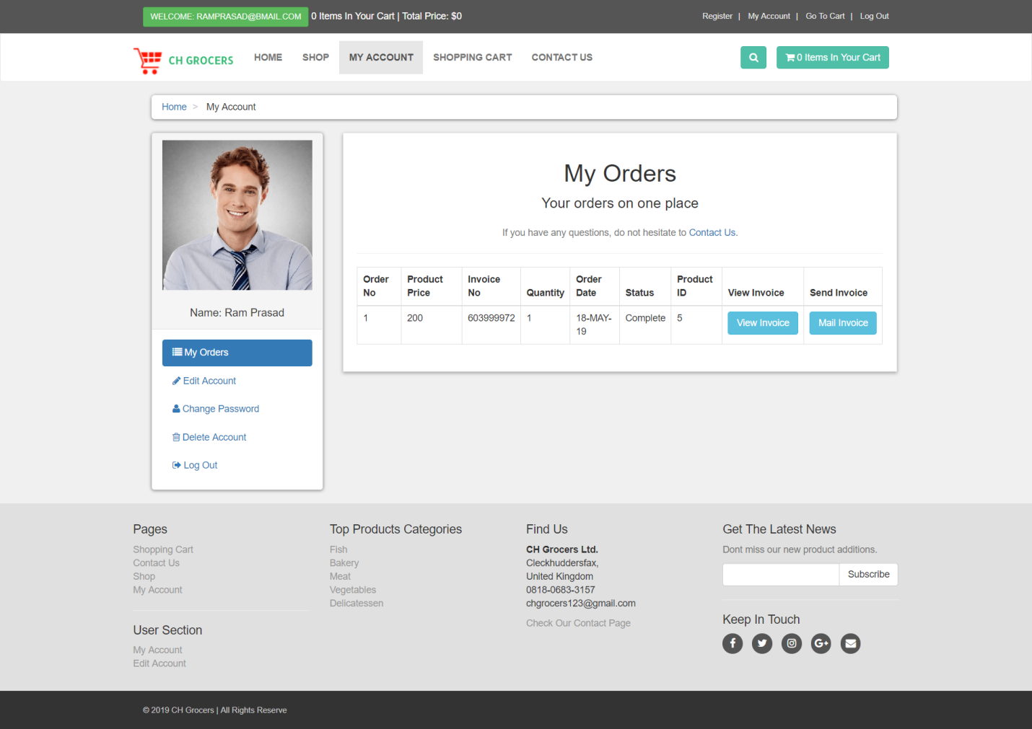

# Edit Profile

To edit your profile first you should login with your valid credentials. After that you should click on my account on the left hand side there you will see a sidebar there you will find edit account

Click on edit account and fill the details again to edit and click update now.

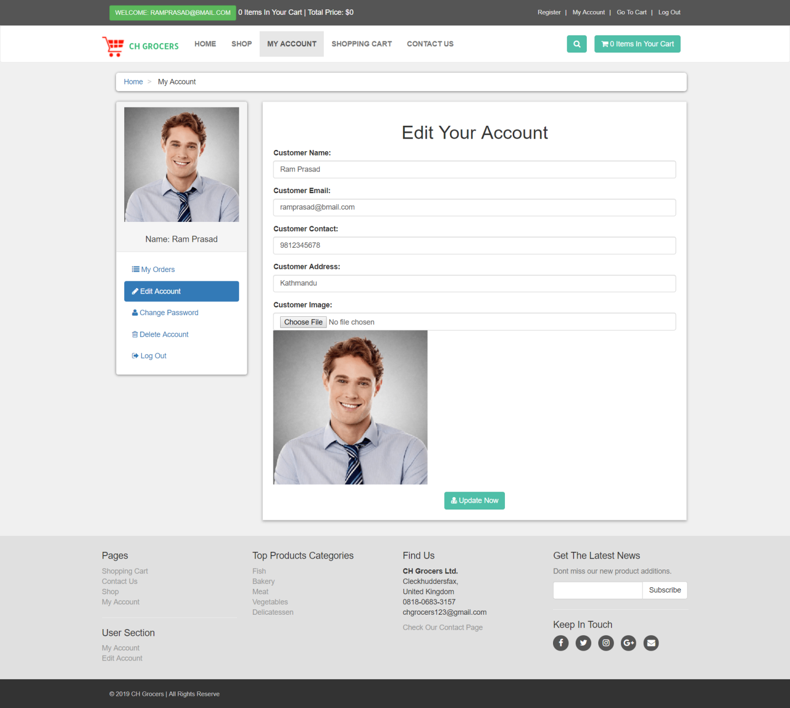

# 

# Delete Account

You can easily delete your account by clicking delete account on left hand side of the sidebar

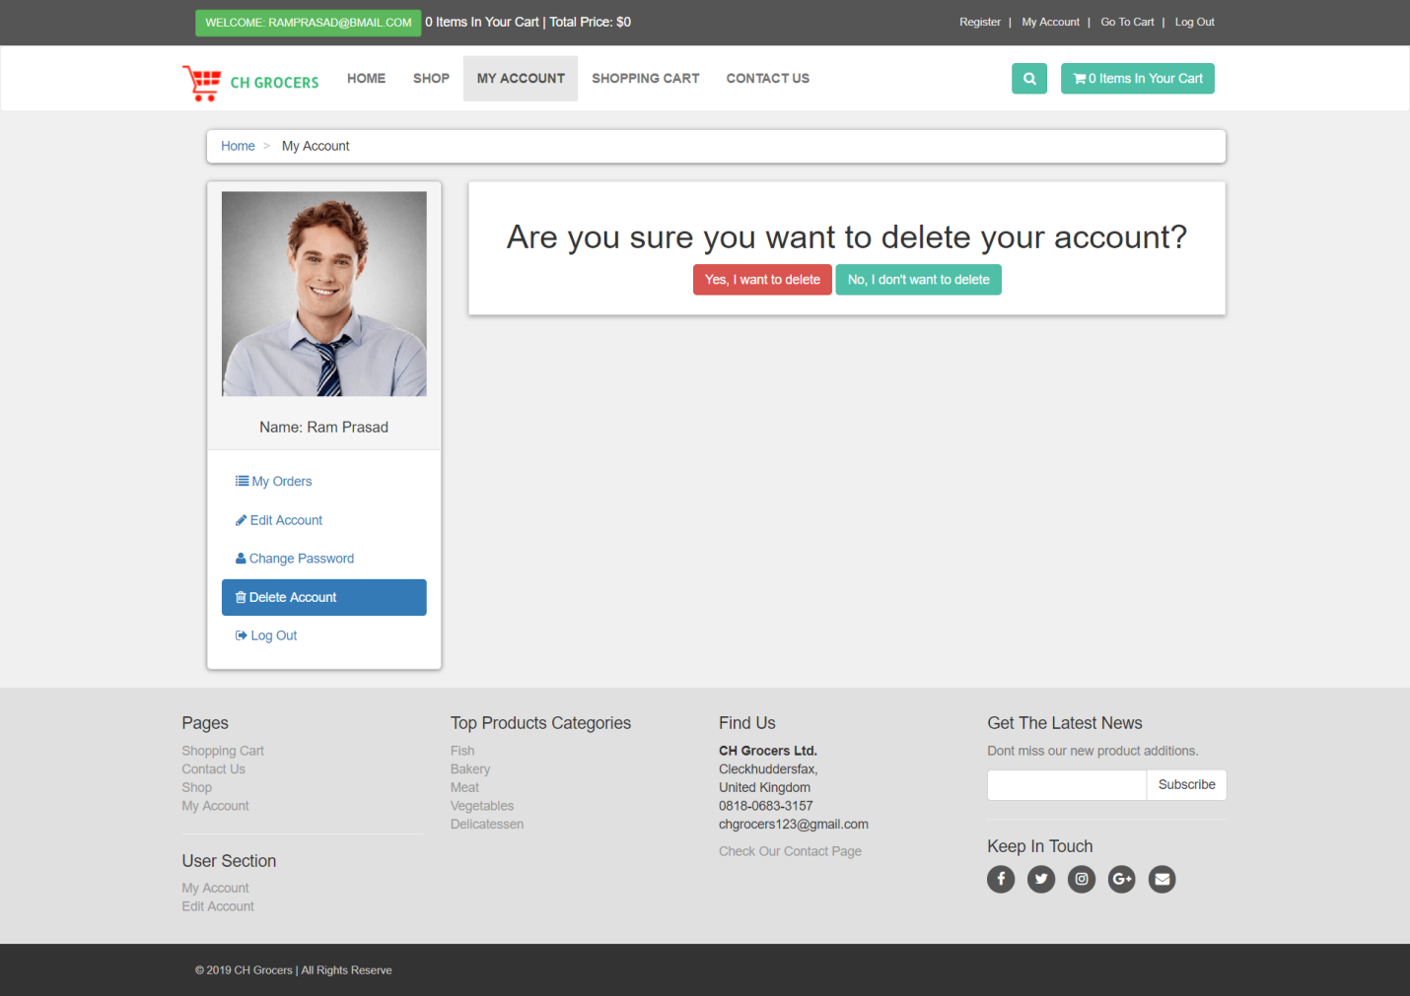

Click on yes I want to delete to delete your account